Street Manager Newsletter No.10
  - Latest news
Street Manager will be a new digital service that will transform the planning, management and communication of street and road works through open data and intelligent services to minimise disruption and improve journeys for the public.
This is the tenth edition of our newsletter.
  - Private Beta
We are about to reach another exciting milestone. Our Private Beta started on 1st May and will last until the end of October. The following organisations have agreed to take part in the initial set of regional groups and we would like to thank them enormously for being so willing to take part.
In Yorkshire and Humberside:
Kirklees Council
Leeds City Council
Northern Powergrid
North Yorkshire County Council
Vodafone
Virgin Media
Wakefield Council
Yorkshire Water

In Southampton:
Scottish and Southern Electricity
Balfour Beatty working with Southampton City Council

In London and the South East:
Essex County Council
Hertfordshire County Council
Royal Borough of Kensington and Chelsea
Southwark Council
Transport for London

One or two others may join these groups and we will provide an update in the next newsletter.
We will also set up some more regional cluster groups from August so please let us know if you are interested in taking part.
We would like to thank those who have taken part in the pilot stage and for all their input.
  - Scope update
As you will have heard by now, the Street Manager project has obtained extra funding from the Kent and TfL Lane Rental Schemes to deliver extra functionality for the Minimum Viable Product. We’ve been working with representatives from those funds, made up of both highway authority and utility officers, to agree what can be delivered with that funding. They have supplied a neatly ordered list of requests and it’s a great selection of features, some large, some small and we look forward to delivering as many as possible. We’re not quite ready to reveal what these items are but this information will be coming in the near future.
  - APIs
The latest in our series of API Workshops took place on 28th March, with yet another great turnout. Topics included an update on the API Roadmap, Pilot/Private-Beta / Public-Beta timelines, onboarding status update, and documentation plans. We’re happy to report that we received some very positive feedback on the day acknowledging the progress that the team have made since the early workshops last year. The slide deck we used is being sent out with this newsletter and it will be on Slack.
In terms of API Users and numbers, and since our last update:
- 5 API users have been successfully onboarded.
(Pitney Bowes, TfL, Bentley, Yotta, Symology)
- Invites have been sent to another 6.
(Western Power, Yorkshire Water, Itertek, Northern Gas, Newcastle CC, and SGN)
- A further 5 are in the process of being set up.
(Morrisons, Gallagher, FM Conway, AMX Solutions, and Lightsout)
To help with onboarding and looking forward to transition, we’ve also started a series of targeted workshops with the individual EToN Developers to discuss plans, API development progress, and timings. This is providing a good opportunity for the team to discuss direct feedback and support the integrations required.
API documentation
The latest API Specification has now been released (30th April). Along with our onboarding documentation for Private Beta users, a first draft (API) Business Rules documentation and the Swagger documents, the documentation set required to support API usage is really now taking shape.
We’ve also added additional support channels. Details about Street Manager communication channels and how to get support during Private Beta are documented here: https://departmentfortransport.github.io/street-manager-docs/onboarding/#communication-channels.

What’s new in Street Manager
Welcome to our regular section of the Street Manager newsletter which highlights an aspect of Street Manager that differs from the EToN technical specification.

If and how to introduce the concept of District Codes into Street Manager was something that involved much careful thought. The result of that deliberation is that Workstreams are the Street Manager equivalent of District Codes. We didn’t need to bring all the information from the OD file into the new system. We don’t need to know your web service URL, your FPN payment details or what version of EToN you are running, so our Workstreams are simply to assist you as a promoter to divide up your work for reporting and permission purposes.

You can see below what information is required. We will know your two-letter prefix and you then record a number in the system. This maintains the two letter, three number convention from the OD file today which aids continuity with the existing process. We’ve discussed this process with a number of industry stakeholders and are confident it serves all needs.

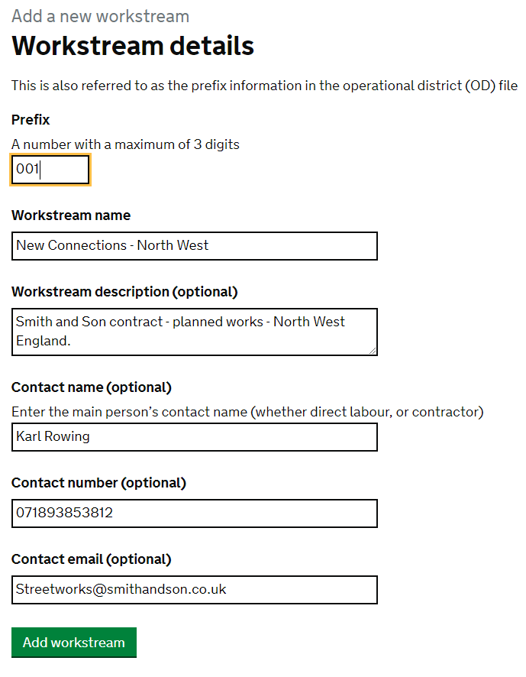

What we did in the last few weeks

In the last few weeks we have:
- Completed our program of roadshows across the country. Thanks to all those who attended. The slide deck is being sent with this newsletter and is on Slack.
- Closed Phase 1 of the project and moved into Private Beta on 1st May.
- Added the ability to search by co-ordinates on the map, the function to revoke a permit and made improvements to the work record.
- Added the ability to record workstreams – see detail above.
- Developed our documentation including
  - a summary of Street Manager that provides a glance at everything we know about the system. This is being sent out with this newsletter
  - other elements of the business change toolkit. These will be sent out as soon as they are ready.
  - The API information detailed above.

What we will be doing in the next few weeks

In the next few weeks we will:
- Present to London and Anglian HAUC, HAUC UK and the GeoPlace Conference.
- Continue Private Beta and work closely with our participating organisations.
- Began building features around advanced filtering and contractor permissions. Look out for more on this in a future ‘What’s new in Street Manager column’.
- Send out the first set of business change documentation, tools and templates to support you to start preparing for transition (see more details below in the business change section)

News from the business change team

If you came to the spring roadshows, you will have met our new business change team. The team wanted to say thank you to all of those who have engaged with us so far. We have been gathering and analysing opinions from users including:
- 114 survey responses
- More than 350 participants in our feedback gathering exercise at the roadshows
- 1-2-1 contact with SMEs
We have taken on board what you have been telling us and have created an overarching document based on feedback at the Newcastle roadshow. You should have received this and hopefully it will help with building your understanding of the change.
What’s next?
We are currently finalising the first part of our Playbook of tools, templates and materials, which will help you with setting up the change and provide you with content including impact assessment and stakeholder analysis tools.
Regardless of when you plan to move to Street Manager, this documentation will enable you to understand better how you will be impacted and how ready your organisation and stakeholders are. It will help you to identify strategic benefits and business value that Street Manager can unlock for your organisation, and will ultimately equip you with the tools and understanding to start planning how to go through the transition. We will share this with you in May.
We would still love to hear from you so do get in touch via the Street Manager email address or slack channel if you have any change related questions/comments.
We understand that most of you work with contractors to deliver works - chances are that they will need to move to Street Manager too in order to continue communicating with you. So please share Street Manager updates and public documents with them and encourage them to talk to us if they have questions or need any more information!

Roadshows

Thank you to all those who came to one of the spring roadshows. The slide deck is being sent out with this newsletter. Please also see the links to the latest episode of ‘The Hole Story’ on Youtube.
[Paul – include links and also the new one]

Contact details

Many thanks to everyone who has sent in their contact details.
If anyone would still like to be added to our list, please send to this email streetmanager@dft.gov.uk
- The name of your organisation
- The Street Works manager (name and email address)
- Others who would like to receive this newsletter directly
- Your key IT contacts

Keeping in touch
We are pleased that so many of you have signed up to our Slack channel. We now have 586 members. Please sign up as we are using this to answer questions, give updates and ask you some detailed questions. Users will also be able to share knowledge amongst themselves.
You can also get it as an app, and it's a free forum. Just to note, when signing up, please put your organisation in your display name as that helps identify you. Please also ask questions and generate discussions.
There is also now a document store where you can find previous newsletters and slide decks.
Please sign up here

